Title of the manuscript’s Asian Health, Science and Technology Reports
First Author¹, Second Author², …… and Last Author¹*

¹Department, Faculty, University, City, State/Province (if any), Postcode, Country
²Department, Faculty, University, City, State/Province (if any), Postcode, Country
^{x}Department, Faculty, University, City, State/Province (if any), Postcode, Country
* Corresponding author. E-mail address: xxxxxx@xxxx.xx.xx
Received: xx Xxxxxxxx 20xx; Revised: xx Xxxxxxxx 20xx; Accepted: xx Xxxxxxxx 20xx; Available online: xx Xxxxxxxx 20xx

Abstract
The abstract should summarize the content of the paper. The maximum number of words in the Abstract is 600 and must be written in a single paragraph. Do not have references or displayed equations in the abstract. The manuscript you prepare, and submit as a Word document, should be fully and correctly formatted. You must spell check and grammar check (F7). All text must be formatted by Style. If you don’t understand about Styles, view the videos on the Graduate School website. The document format includes: Paper Size = A4, Orientation = Portrait, Margins = Top 2.5cm, Bottom = 2.5 cm, left = 3 cm, right = 2.5 cm, apply to whole document.

Keywords: journal format, printing, references (not more than 5 words)

Introduction

All the major headings are Heading 1 Style.
This is an example of a Normal paragraph, that is, a usual paragraph that has been stated as Normal Style. Submitted paper should be in English. There is a limit of 8-20 pages for each paper in the Journal.
The paper should have logical sections, Introduction, Methods and Materials, Results, Discussion, Conclusions and Suggestions, Acknowledgements, Author Contributions, Conflict of Interest, Funding and References, in Heading 1 style.

Methods and Materials

Where sub-headings are used, they should be in Header 2 Style. The standard, or normal, paragraph should be in Normal Style. Where authors have images or pictures that are .jpg format or other graphics format, Authors should format them as Wrap Text, Tight.

Example sub-heading: Inserting a Figure

Text following the Header 2 sub-heading

Results

Where sub-headings are used, they should be in Header 2 Style. The standard, or normal, paragraph should be in Normal Style. As is the case in all of the paper, paragraphs should be in Normal Style. When authors are showing their results in tables, authors should define a new style and call it Table Data Style. Similarly, you should define a Table Figure Label Style. Using these 2 styles sets the formatting of those separately from Normal style. If you do not understand about this, you should view the videos on the Graduate School website.

Example sub-heading: Formatting Tables
Text following the Header 2 sub-heading, which should be in Normal Style.

Table 1 This is a brief label that links the table to your discussion (Example)
Position | Male |  |  | Female |  |  | Total
 | Left | Right |  | Left | Right |  | No. | (%)
1 | 0 | 0 |  | 1 | 0 |  | 1 | 0.21%
2 | 0 | 0 |  | 0 | 1 |  | 1 | 0.21%
3 | 56 | 49 |  | 138 | 133 |  | 376 | 40.09%
4 | 73 | 78 |  | 156 | 167 |  | 474 | 50.53% *
5 | 24 | 25 |  | 21 | 15 |  | 85 | 8.75%
6 | 0 | 1 |  | 0 | 0 |  | 1 | 0.21%
Total | 153 | 153 |  | 316 | 316 |  | 938 | 100%
* p < 0.05
Here authors can enter any narrative or further information allowing the table to be fully understandable. But this is not the place for a full analysis and discussion of the data. That is done in the main text of the Results Section.
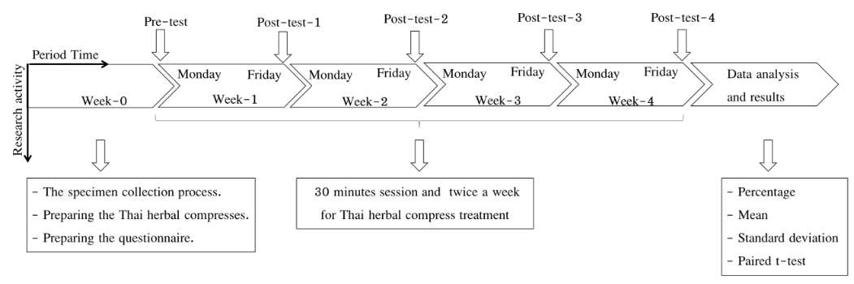

Figure 1 This is a brief label that links the table to your discussion (Example)

Discussion

Where sub-headings are used, they should be in Header 2 Style. Where sub-headings are used, they should be in Header 2 Style. The standard, or normal, paragraph should be in Normal Style. The results and discussion parts may be combined.

Example sub-heading 3

Conclusion and Suggestions

In this section there may be sub-sections, with sub-section headings. These should be styled as Heading 2 style.

Acknowledgments

In this section authors include all of the acknowledgments as guided in the guidelines and publication ethics. Funding is not included in this section and this section could be omitted in case of no acknowledgements.

Author Contributions
In this section authors have to identify the contribution by each author to the manuscript in the following types of contributions; Conceptualization, Development or design of methodology, Providing of materials subjects or patients, Investigation, Collection of data, Data analysis and interpretation, Manuscript writing, Manuscript review and editing, and others (specify the contributions)
Author 1: contribution….
Author 2: contribution….
Author 3: contribution….

Conflict of Interests

All authors declare that they have no conflicts of interest. (Amend this declaration statement in case authors have any potential conflict of interest)

Funding

The funding information, names of funding agency/organization and grant numbers (if any), will be included in this section. Otherwise, authors may indicate that the authors received no financial support for the research of this article.

References

Hininger-Favier, I., Benaraba, R., Coves, S., Anderson, R. A., & Roussel, A. M. (2009). Green tea extract decreases oxidative stress and improves insulin sensitivity in an animal model of insulin resistance, the fructose-fed rat. Journal of the American College of Nutrition, 28(4), 355-361.
Moyers, R. E. (1988). Handbook of Orthodontics (4th ed.). Year book medical.
Pope, J., & Owen, A. D. (2009). Emission trading schemes: Potential revenue effects, compliance costs and overall tax policy issues. Energy Policy, 37, 4595-4603. http://dx.doi.org/10.1016/j.enpol.2009.
06.014
Prayag, I. L., & Ramjee, R. (2009). The impact of Newcastle disease control on smallholder poultry production in Mauritius. In R. G. Alsers, P. B. Spadbrow, & M. P. Young (Eds.), Village chickens, poverty alleviation and the sustainable control of Newcastle disease: Proceedings of an international conference held in Dar es Salaam, Tanzania, 5-7 October 2005 (pp. 132-134). ACT: Australian Centre for International Agricultural Research.
Roberts, S. (2020, April 9). Early string ties us to Neanderthals. The New York Times. https://www.nytimes.com/2020/04/09/science/neanderthals-fiber-string-math.html

